The Background of Cartoons on the Way of Silk Route

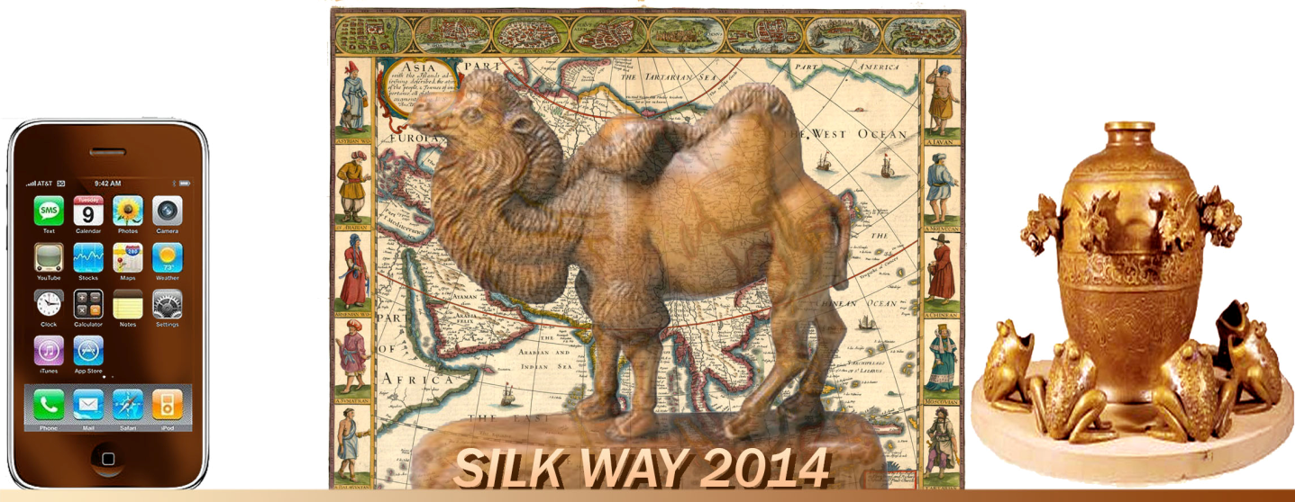

The Silk Road, or Silk Route, is a series of trade and cultural transmission routes that were central to cultural interaction through regions of the Asian continent connecting the West and East by linking traders, merchants, pilgrims, monks, soldiers, nomads and urban dwellers from China to the Mediterranean Sea during various periods of time.

Extending 4,000 miles (6,437 kilometers), the Silk Road gets its name from the lucrative Chinese silk trade which was carried out along its length, and began during the Han Dynasty (206 BC – 220 AD). The Central Asian sections of the trade routes were expanded around 114 BC by the Han dynasty, largely through the missions and explorations of Zhang Qian. They took great interest in maintaining the safety of the products they traded and extended the Great Wall to ensure the protection of the trade route.

Trade on the Silk Road , was a significant factor in the development of the civilizations of China, the Indian subcontinent, Persia, Europe and the Arab World. It opened long-distance, political and economic interactions between the civilizations. Silk was certainly the major trade item from China, but many other goods , various technologies, religions and philosophies, as well as the bubonic plague (the "Black Death"), also traveled along the Silk Routes. In addition to economic trade, the Silk Road served as a way of cultural dialogue between the networking civilizations.

The main traders during ancient times were the Indian and Bactrian traders, then from the 5th to the 8th century the Sogdian traders, then afterward the Arab and Persian traders.

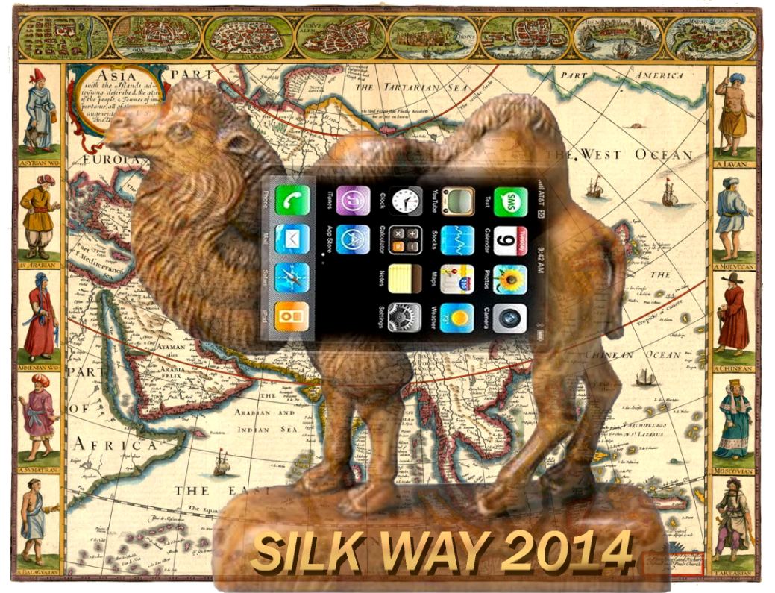

Modern Day

The Eurasian Land Bridge is sometimes referred to as the "New Silk Road". The last link in a railway route along the Silk Road was completed in 1990, when the railway systems of China and Kazakhstan connected in Alataw Pass (Alaskan Kou). Currently (2008), the line is used for direct passenger service from Urumqi in China's Xinjiang to Almaty and Astana in Kazakhstan.
Since July 2011 , Chongqing is officially linked to Duisburg, Germany by a freight rail line across Eurasia. Compared to the traditional sea trade routes from Guangzhou and Shanghai, the rail link to Europe cuts travel time from about 36 days by container ship to just 13 days by freight train. As of 2013, HP has been moving large freight trains filled with laptop computers and monitors along this rail route.
Since 1993 , the United Nations World Tourism Organization has commenced an international program to develop sustainable tourism along the route to foster peace , tolerance and love between peoples.

VALUE

Even though silk was the main commodity it was not the only trade good transported on transcontinental road. Central Asia exported very valuable horses to China along with military equipment , gold , silver, semiprecious stones, glass products, leather, wool, carpets, cotton fabrics, exotic fruits - melons and peaches, fat-tailed sheep, hunting dogs, leopards and lions. Caravans brought from China porcelain, metal ware, lacquer ware, cosmetics, tea and rice. In the road bags merchants could find elephant tusks, rhinoceros horn, tortoise shells, spices and much more. In 15th century, Italian tableware was made in imitation of Chinese products.

The Great Silk Road played a major role in the development of economic and cultural relations of the minority peoples of Asia, the Caucasus , Central Asia and China. For example, it served as conduit for the spread of technology and innovation. This included spreading the arts of dance, music, visual arts, and architecture, as well as the religions of Christianity, Buddhism, Islam, and Taoism.

