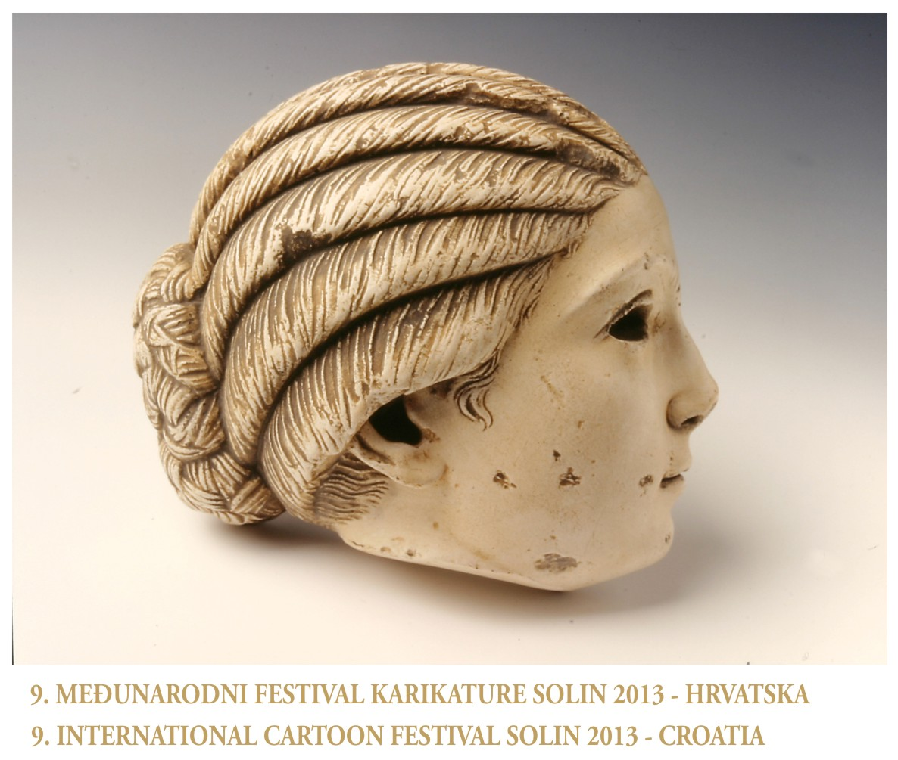
9.INTERNATIONAL CARTOON FESTIVAL - SOLIN 2013 (CROATIA)
- PARTICIPATION
The organizer of 9th International festival of cartoon Solin 2013.Is the city Solin.The festival is opened for everyone regardless of nationality, age,sex, or profesion.

2.THEME: 1. FREE
2.ARHEOLOGY

3.ENTRIES
Conditions of entry:
1. All entries must be original cartoons. Framed works,also,will not be accepted.
2. Entries can be either black and white or colored.
3. There should be the name, surname and the address on the reverse side of cartoons.
4. Maximum 5 entries will be submitted.
5. Maximum size of entries is A3 format (40x30cm)

4.DEADLINE
Entry deadline is the 10. august. 2013. Please write ; PRINTED MATTER- NO VALUE:

5.ADDRESS
9.INTERNATIONAL CARTOON
FESTIVAL SOLIN 2013
«DOM ZVONIMIR»
Kralja Zvonimira 50,
21210 Solin, CROATIA

6.PRIZE AND AWARDS

- PLAQUE....................................................1009 EUR
- PRIZE CITY SOLIN................................... 3 PRIZE

7.EXHIBITION
The exhibition will take place in the galery of the culture home „ZVONIMIR“ Solin on the 21.08.2013.

8.OTHER CONDITIONS
Authors of works that quality to the exhibition are given a presentation copy of the exhibition catalogue (DVD). The works will be returned only on the special reqest of an autor.The postage EUR5 will be paid by autor. The organizer reserves the right to reproduce the works sent to the festival, Solin 2013, as the advertising material without being obliged to pay a fee to an author whose work may be used.The prize-winning works become property of the organizer.
PRESIDENT 9.INTERNATIONAL
CARTOON FESTIVAL- SOLIN 2013
CROATIA

Cartoonist-designer
MARKO IVIĆ

ENTERY FORM

LAST NAME ---------------------------------------------

FIRST NAME --------------------------------------------

PSEUDONIM --------------------------------------------

STREET ---------------------------------------------------

POSTCODE -----------------------------------------------

CITY -------------------------------------------------------
COUNTRY -----------------------------------------------

TELEPHONE --------------------------------------------

E-MAIL ---------------------------------------------------

NUMBER OF ENTRIES -------------------------------

MALE-FEMALE ----------------------------------------

